**University of Petroleum and Energy Studies**

School of Computer Science

Department of Cybernetics



**Graphics & Animation Tools**

**LAB FILE**

**(Session: 2020-2021)**

Course: B. Tech with Specialization in Open Source and Open Standards

Batch: 2017-2021

Semester: VIIth

**Submitted By: -**

Ananya Raghav

R100217008

500062570

**Submitted To: -**

Dr. Durgansh Sharma Assistant Professor

Department of Cybernetics

**Experiment – 10**

**Aim-** Design of building using blender.

**Steps followed-**

1. Open Blender
2. Clear the interface.
3. Start with adding a plane to act as the base.
4. Now, add a cube and scale it to look like a cuboid(main structure of the building).
5. Now, take a plane and scale it and position it on one of the sides of the base cube(to represent windows).
6. Set the surface of the plane representing windows to Glass BSDF to give a glass like effect.
7. Add the plane representing windows as per the size of the base cube.
8. Do the same as in step 5 to all the sides of the cube.
9. Now choose a front side of the building, make another plane and scale and fix it at the bottom of the base cube representing the door of the building.
10. Fill colors in all the shapes by going to Materials.
11. Select Surface and their choose the color of your choice.
12. Go to file and save it as your name and render a few pictures for the display.

**Output-**

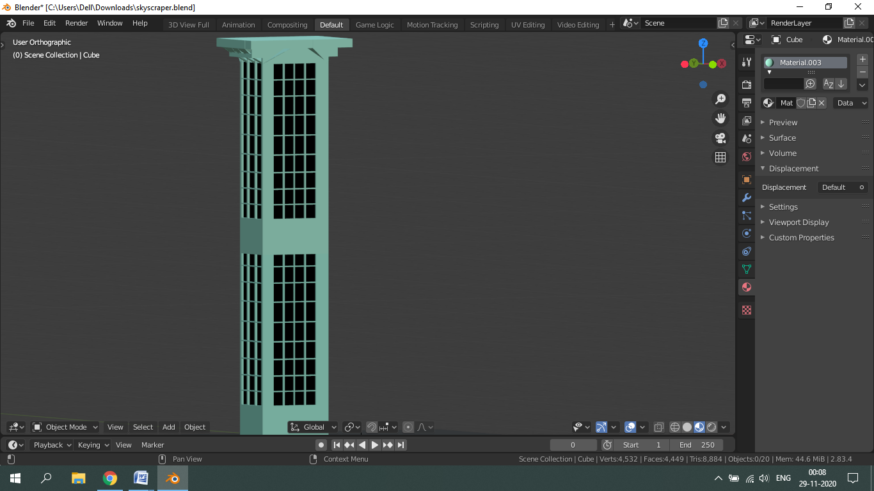

**Drive Link-**

<https://drive.google.com/drive/folders/1rgfW8GbE_0_JAfHPgFtm5HZt2AxhWUI8?usp=sharing>